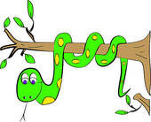
Reading Adventures Await
May Reading Log

Name: ____________________________________________________
Teacher: _______________________________
Get in on the adventure and read each day! When you have completed your log have your parents sign below. Hold on to this form and return it to your teacher at the end of the month. Happy Reading!
Directions: Read 4 books with your family. Draw a picture of your favorite part in each picture box. Don’t forget to write down the title for each book.
Book Title: __________________________________
Please turn the page over to continue your reading log!
Book Title: __________________________________
Book Title: __________________________________

Book Title: __________________________________

_____________________________
it to your teacher in September with your July reading record!
e this record of your reading and return it to your teacher in September with your July reading record!

Parent/Guardian Signature
Don’t forget to save this record of your reading and return it to your teacher at the end of the month.

